**SCCM application content update**

* update the content in source directory for application
* go to \Software Library\Overview\Application Management\Applications
* select the application you want to update
* at the bottom click on deployment type
* select the deployment
* right click on it and select update content

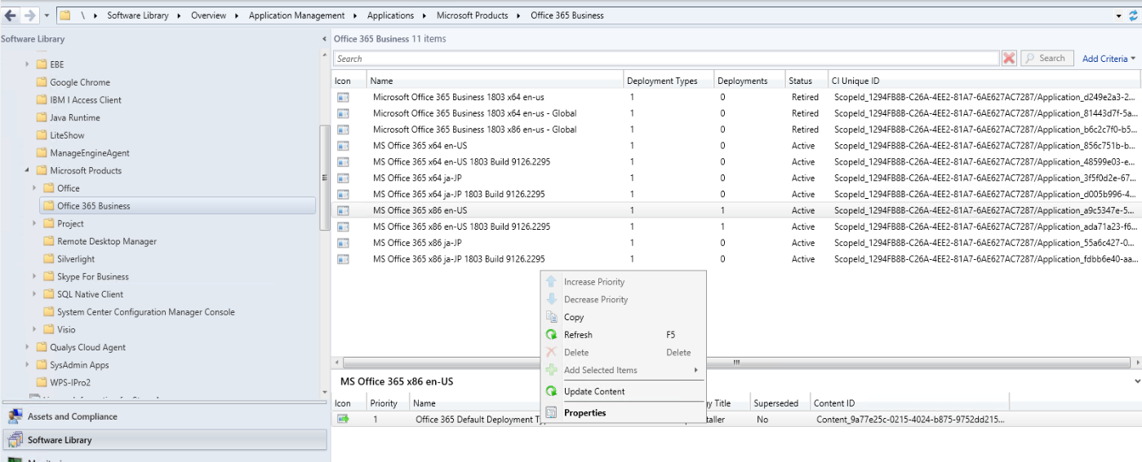

* check the distmgr.log, in the sccm installation directory, under logs on SCCM site server e.g Program Files\Microsoft Configuration Manager\Logs\distmgr.log

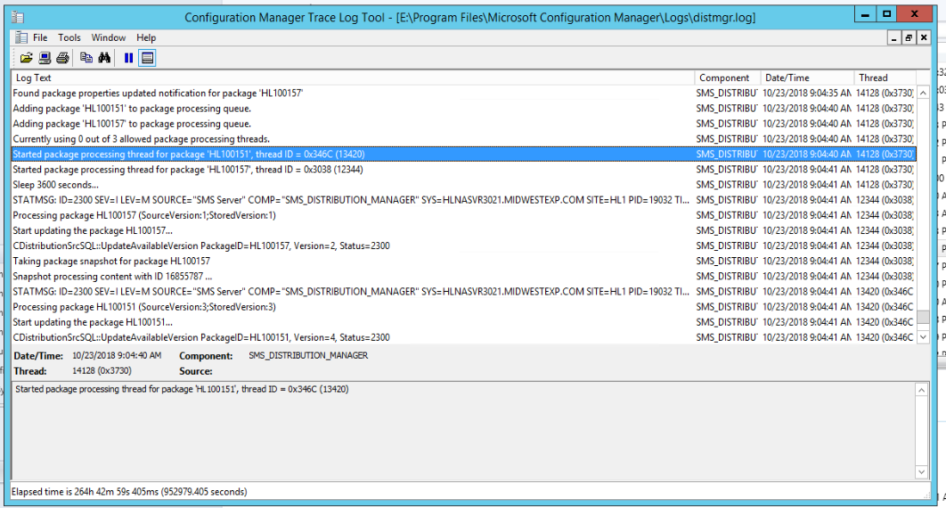

* go to monitoring tab and check the content status for the updated application, it should distribution in progress

